PROJECT ON "BILLING SOFTWARE FOR SMALL SCALE BUSINESS ORGANISATION"

ENTER YOUR PASSOWRD TO START THE APPLICATION PRIVATELY
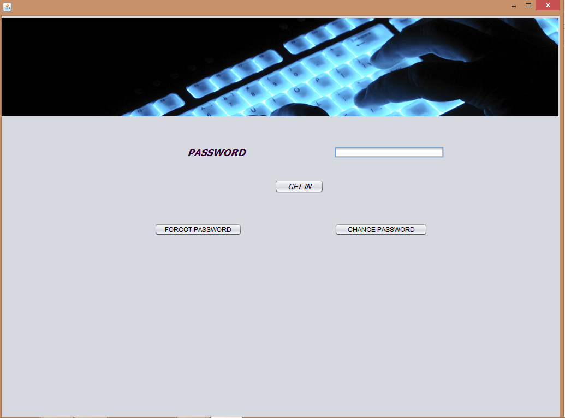
use FORGOT PASSWORD button to reset your password using security question or use change password button to change password by using current password

WELCOME PAGE NOW OPENS :
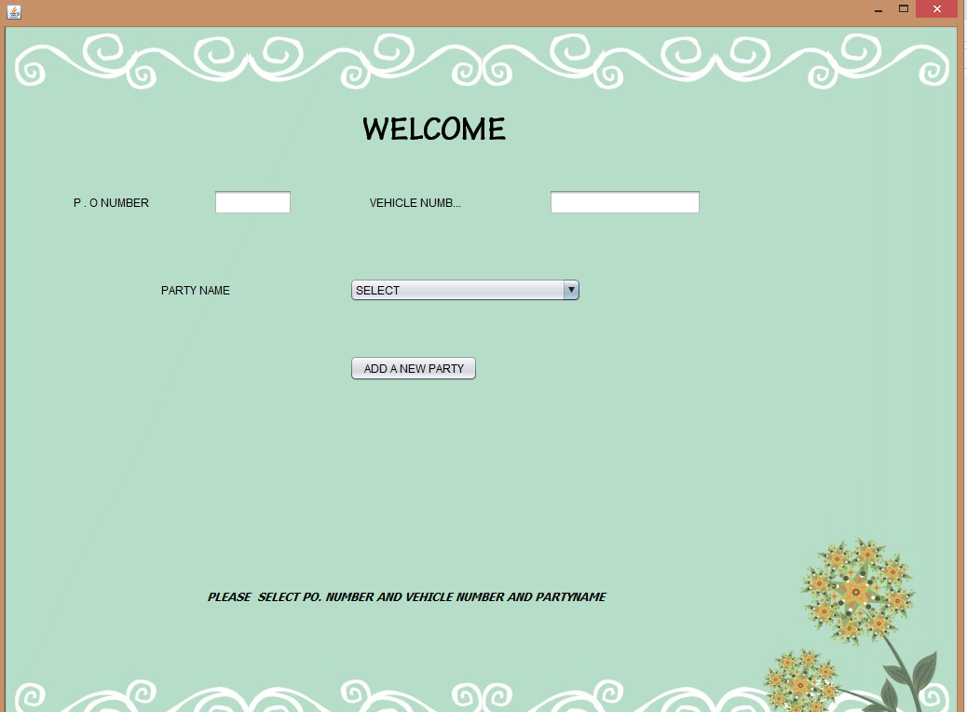
ENTER THE PO NUMBER AND THE VEHICLE NUMBER OF THE COSTOMER TO SEND THE GOODS TO THAT COSTOMER.
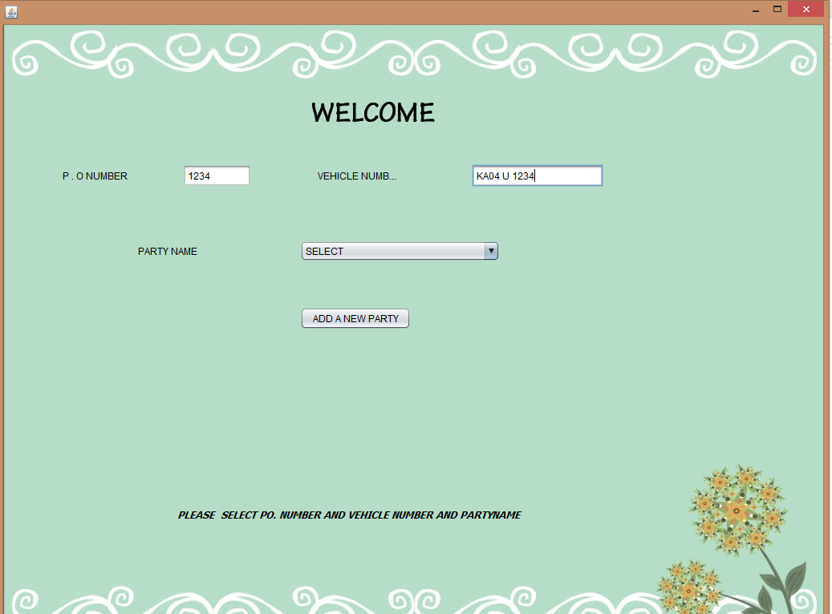
IF YOU WANT TO ADD A NEW PARTY NAME PRESS "ADD NEW PARTY BUTTON"
THEN IT GIVES THIS
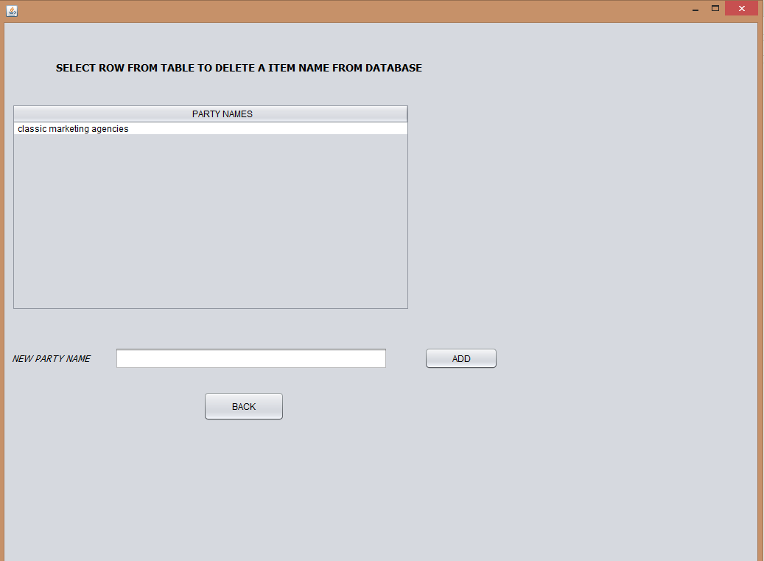

ENTER PARTY NAME YOU WANT AND PRESS ADD BUTTON TO ADD IT INTO THE DATABASE
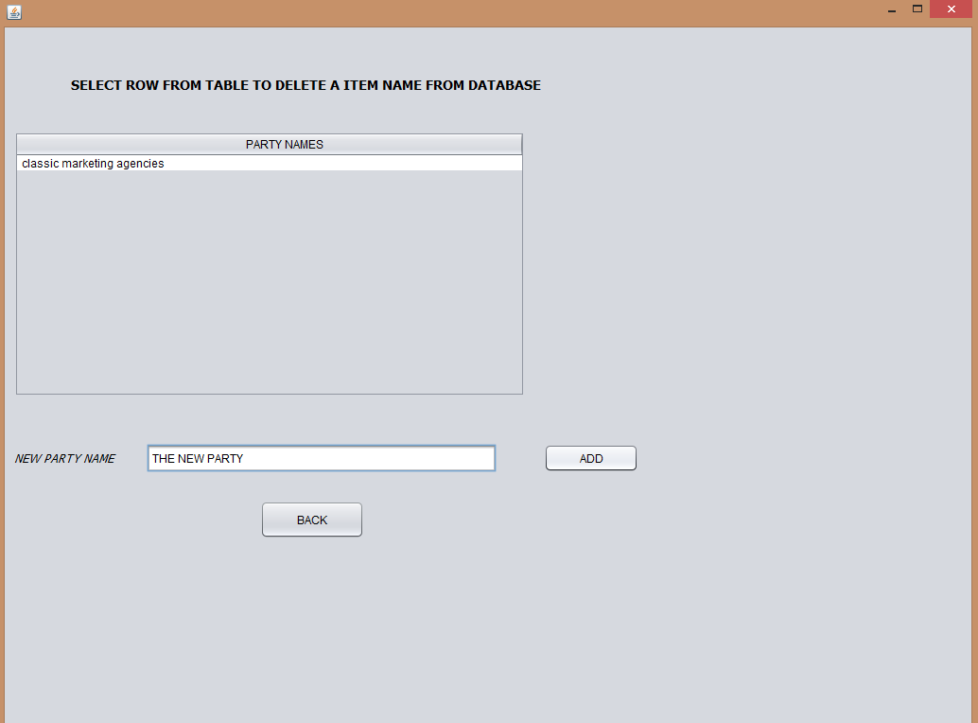

AFTER PRESSING THE ADD BUTTON FOR SUCCESFUL ENTRY YOU GET THIS :
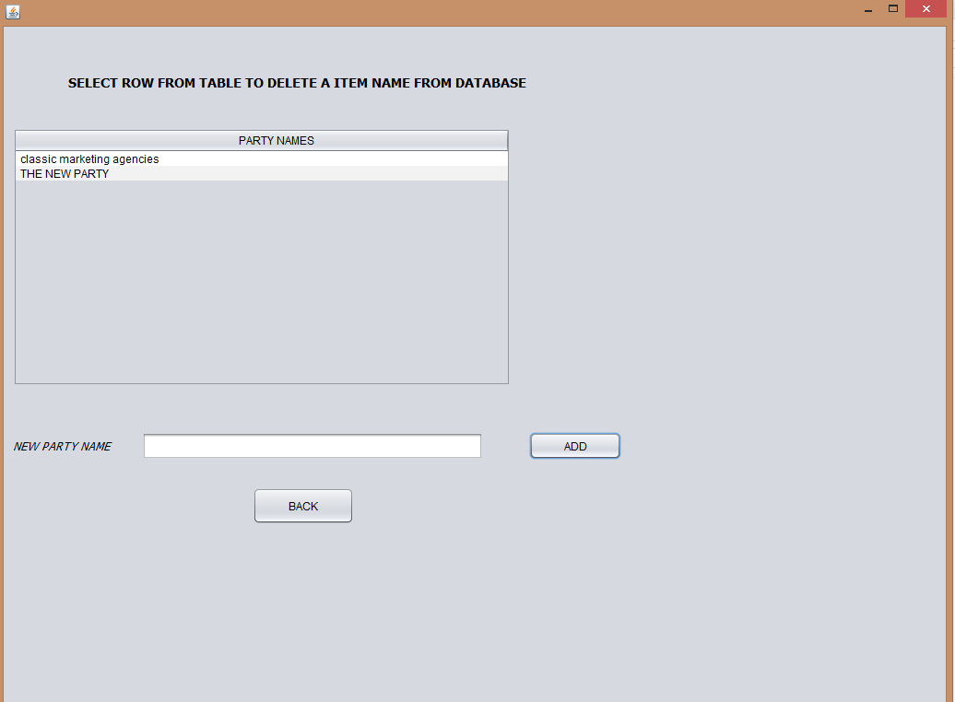

IF YOU WANT TO DELETE A PARTICULAR PARTY THEN PRESS ON THAT PARTY NAME IN THE TABLE AND ENTER DELETE BUTTON TO DELETE THAT PARTY NAME FROM DATABASE
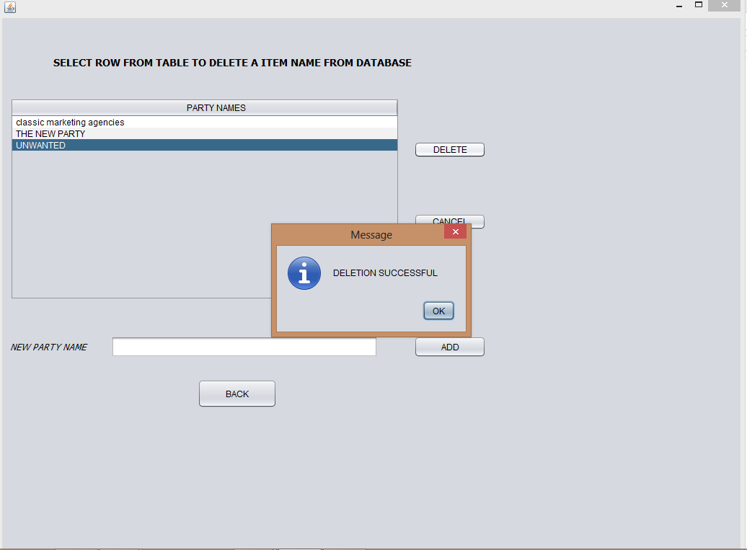

AFTER DELETION THE TABLE LOOKS LIKE THIS :
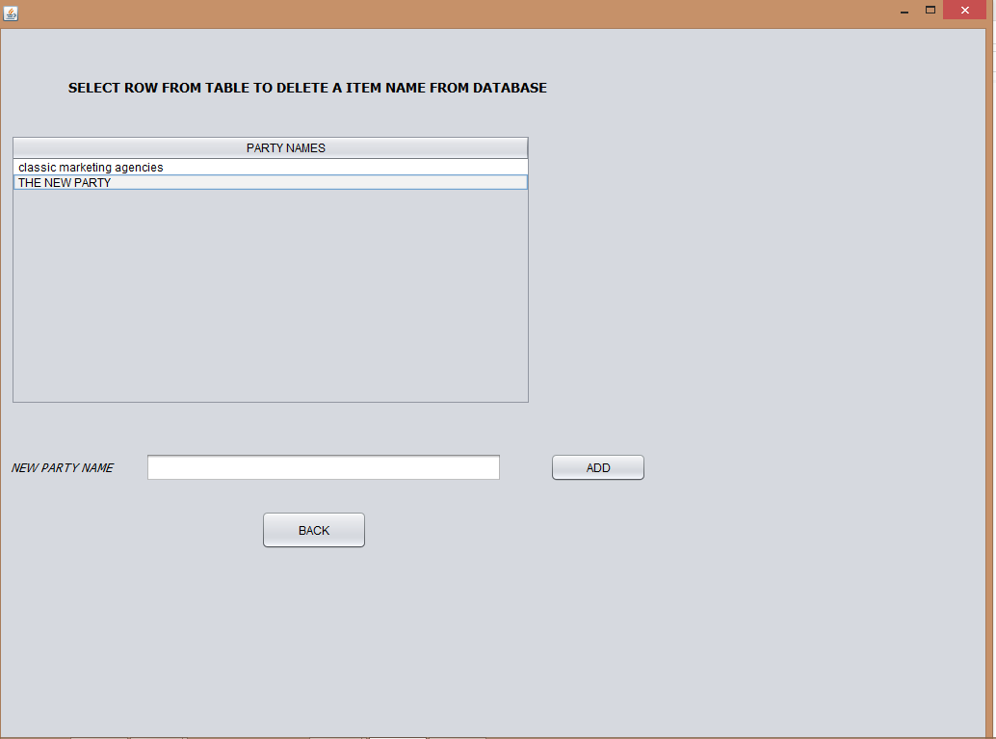

PRESS BACK TO GO AGAIN TO THE MAIN PAGE

ENTER THE PARTY NAME TO GENERATE UNIQUE INVOICE NUMBER ACCORDING TO THE ENTRIES IN THE DATABASE AND ALSO AUTO GENERTAION OF DATE :
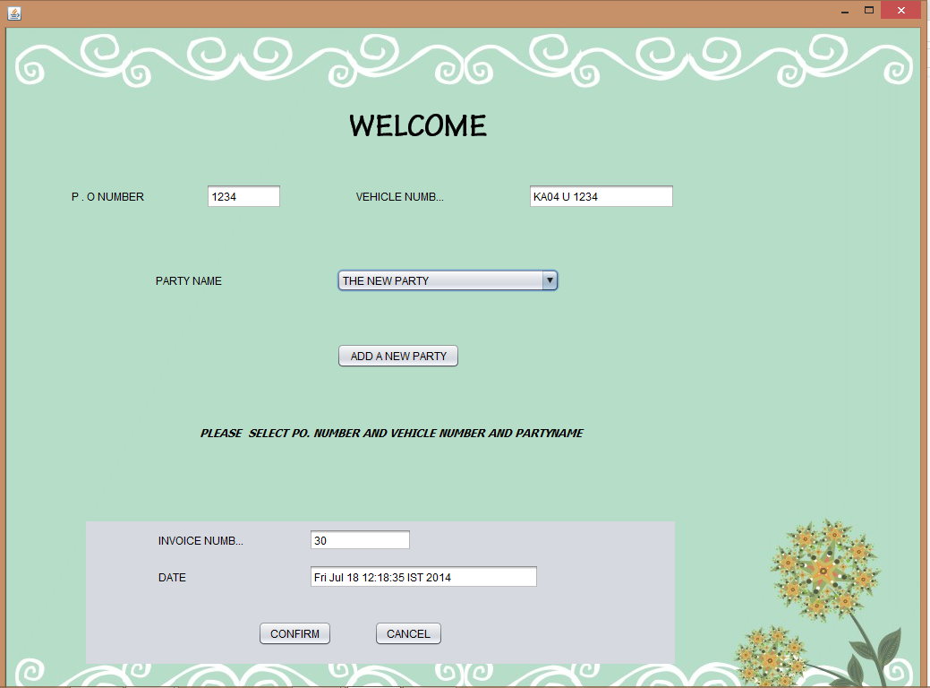
CONFIRM EVERYTHING TO PROCEED NEXT

NEXT PAGE IS FOR BILLING FOR THE SELECTED COMPANY NAME :
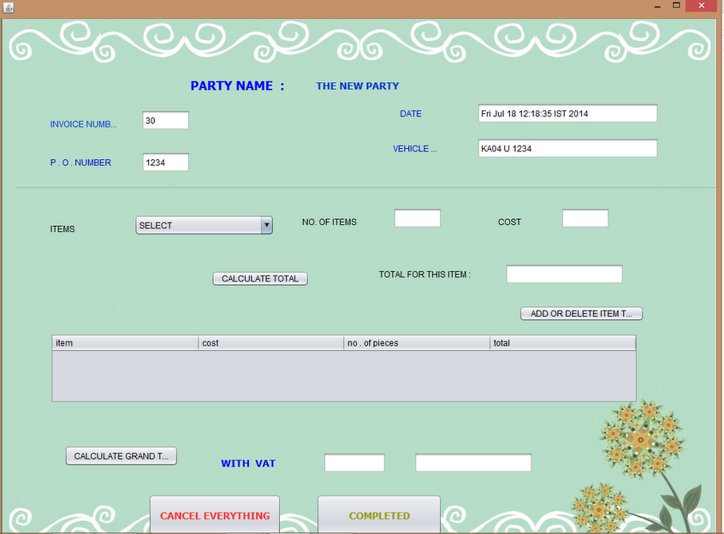
ALL THE DATA WHICH YOU CONFIRMED PREVIOUSLY IS SHOWN CLEARLY AT THE TOP

NOW YOU CAN PRESS "ADD NEW ITEMS" BUTTON TO ADD NEW ITEMS AND THEIR COSTS :
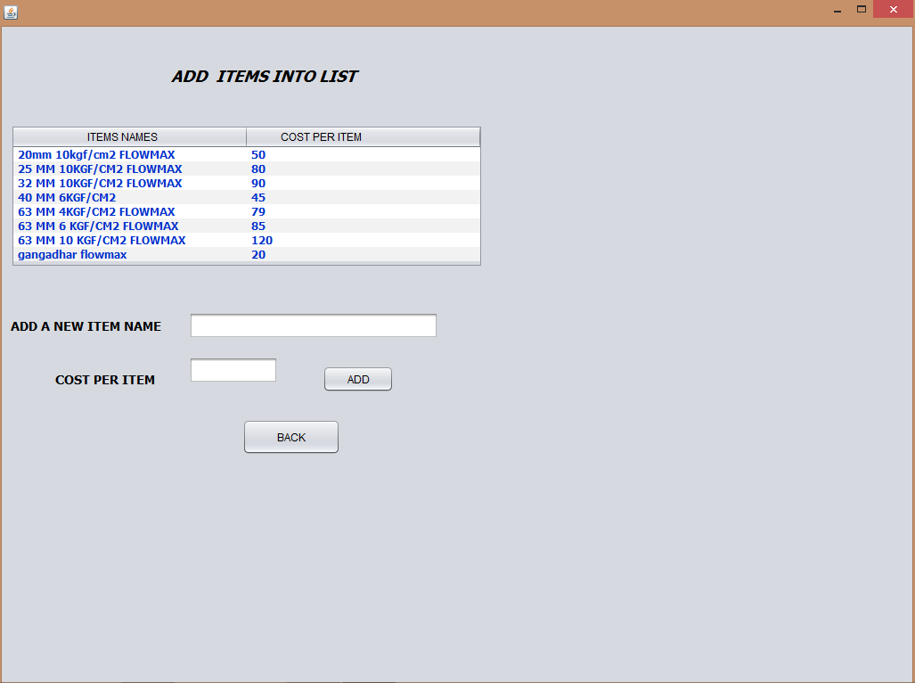
HERE YOU CAN ADD OR DELETE PARTICULAR ITEM AND SAVE IT TO THE DATA BASE AND PRESS BACK TO THE BILLING PAGE

NOW SELECT A ITEM FROM THE DROP DOWN BOX AND THEIR COST WILL BE AUTO GENERATED FROM DATABASE AND PRESS CALCULATE BUTTON TO CALCULATE THE COST FOR PARTICULAR NUMBER OF ITEMS
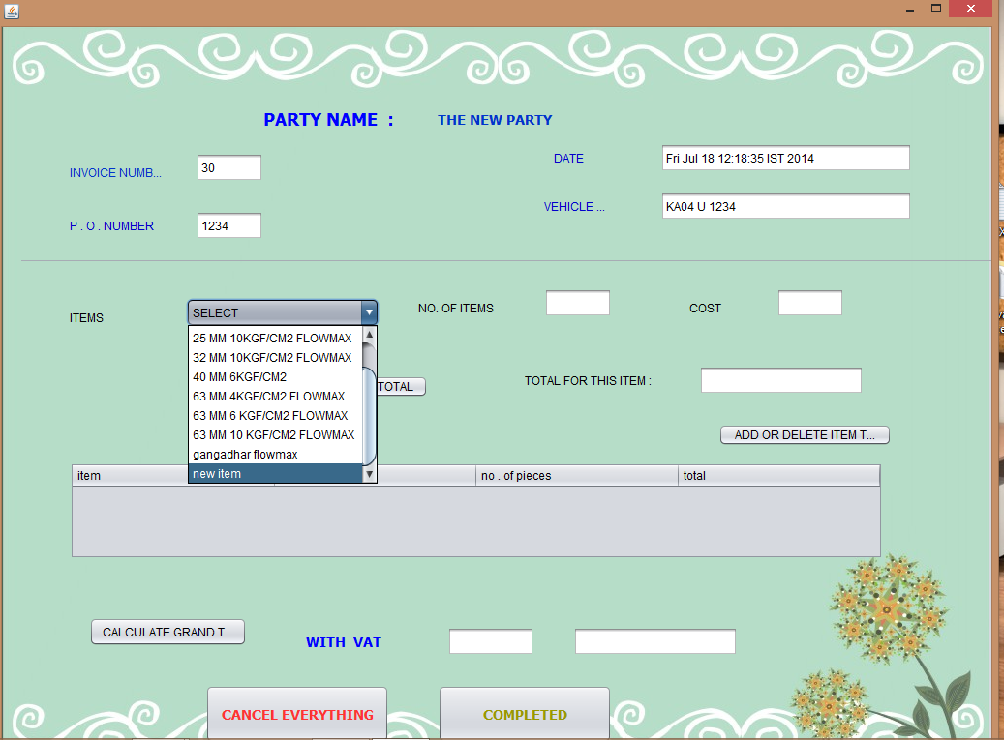
NOW ADD THAT SELECTED ITEM TO THE BILL BY PRESSING ADD TO TABLE BUTTON

AFTER SUCCESSFUL ENTRY INTO THE TABLE THIS LOOKS LIKE THIS :
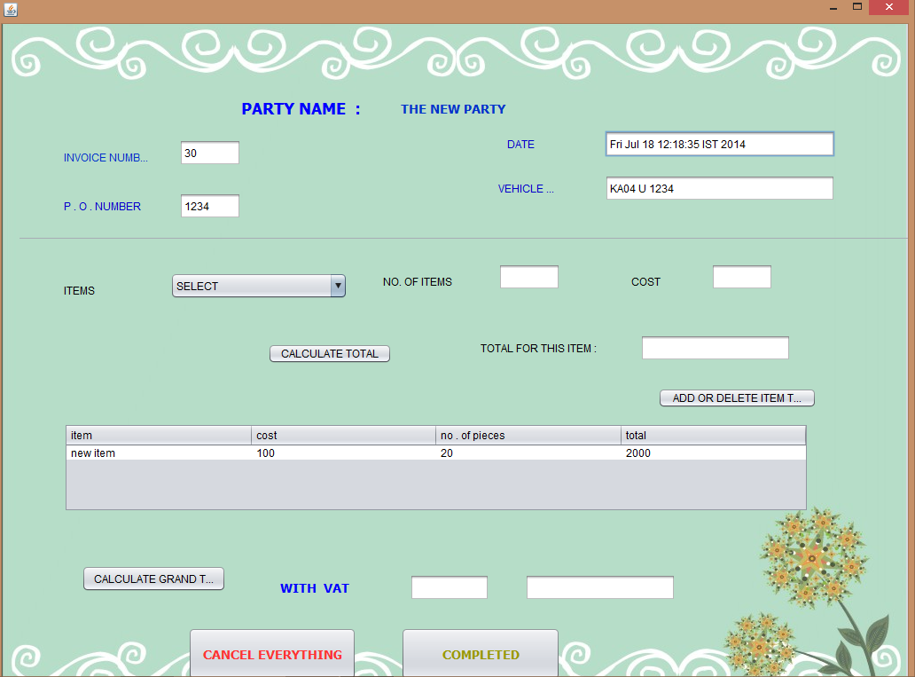
SIMILARY ADD AS MANY ITEMS YOU WANT AND ENTER THE TAX VALUE AND PRESS "CALCULATE GRAND TOTAL "BUTTON TO CALCULATE THE GRAND TOATAL

YOU CAN ALSO DELETE A PARTICULAR ITEM FROM TABLE BY PRESSING IT EXACTLY LIKE IN DELETING A ITEM
NOW AFTER CONFIRMING THE BILL YOU WILL GET THIS :

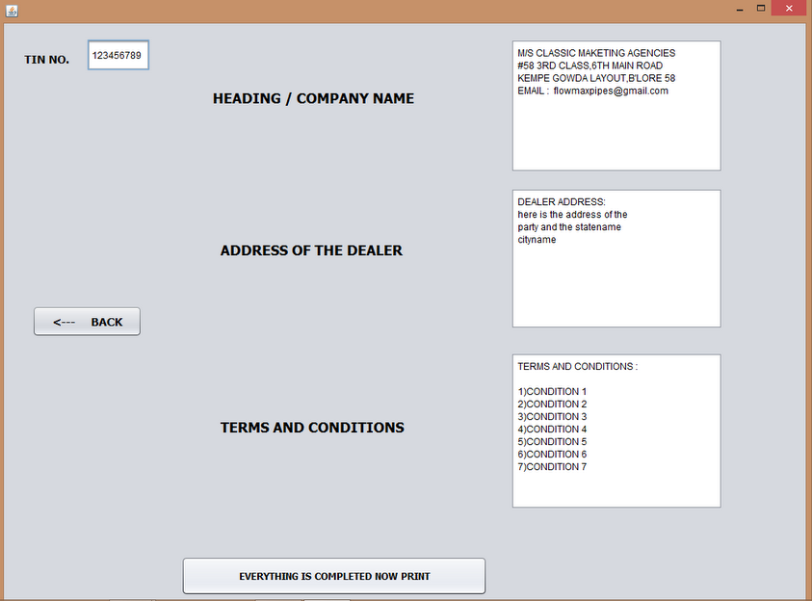
ENTER THE TIN NUMBER AND THE ADDRESS OF THE COUSTEMER AND ADD THE HEADING AS YOUR COMPANY ADDRESS
ADD CLEAR TERMS AND CONDITIONS
AND GO FOR PRINTING USING THE BUTTON BELOW

FINALLY THE PDF FILE IS AUTO GENERATED ACCORDING TO YOUR INPUT LIKE THIS :
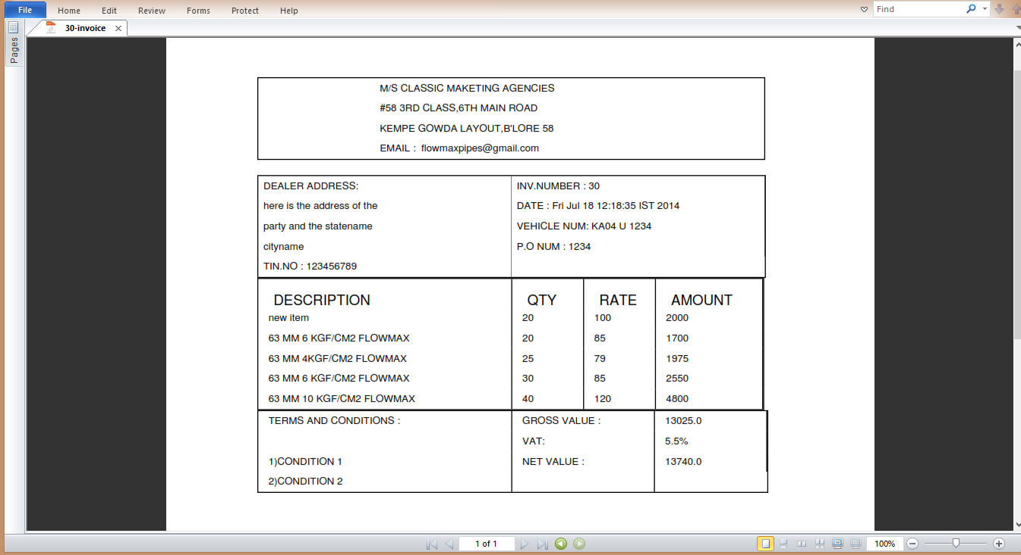

END OF THE DOCUMENTATION

